About the Project
This project is a client/server dashboard developed for Grazioso Salvare. The dashboard connects to the Austin Animal Center Outcomes data stored in MongoDB and allows users to identify dogs that may be suitable for different types of search-and-rescue training.
The dashboard includes interactive filtering options for Water Rescue, Mountain or Wilderness Rescue, Disaster or Individual Tracking, and Reset. The data table, breed chart, and geolocation map update based on the selected filter.
Motivation
The purpose of the project was to create a user-friendly interface that allows Grazioso Salvare to interact with animal shelter data without directly working with the MongoDB database.
The dashboard makes it easier to identify animals that meet specific rescue-training requirements based on breed, sex, and age.
Tools Used
MongoDB was used as the database model because it stores data as flexible documents and works well with Python through the PyMongo library. This allowed the existing animal shelter data to be queried and filtered using the CRUD module developed in Project One.
Python was used for the database interaction and dashboard logic.
PyMongo was used to connect Python to MongoDB and execute database queries.
Dash was used to create the dashboard interface and handle interactions between the user and the database. Dash provides the view and controller portions of the application.
Plotly was used to create the interactive pie chart showing the breeds represented in the current data.
Dash Leaflet was used to display animal locations on an interactive map.
Pandas was used to convert MongoDB query results into DataFrames that could be displayed and analyzed by the dashboard.
Jupyter Notebook and Codio were used to develop and test the application.
Dashboard Functionality
The dashboard begins by displaying the complete Austin Animal Center Outcomes dataset.
Users can select one of four filter options:
- Water Rescue
- Mountain or Wilderness Rescue
- Disaster or Individual Tracking
- Reset
Each rescue option sends a MongoDB query through the CRUD module. The query filters animals based on the breed, sex, and age requirements provided by Grazioso Salvare.
The interactive data table updates with the matching animals. The breed pie chart updates to represent the animals currently displayed in the table. The geolocation map displays the location of the selected animal from the table.
Reset removes the rescue filters and restores the complete dataset.
Development Process
The project began with the CRUD Python module created in Project One. This module was reused to connect the dashboard to MongoDB and retrieve animal records.
The dashboard was first created with an unfiltered data table. Interactive rescue filters were then added using Dash radio buttons.
MongoDB queries were created for each rescue category based on the breed, sex, and age requirements provided by Grazioso Salvare.
Callbacks were added so that the data table updates whenever the selected rescue type changes. A breed pie chart and geolocation map were then connected to the data table so that they dynamically update with the current results.
The Grazioso Salvare logo and developer identifier were also added to meet the client branding requirements.
Challenges
One challenge was managing the interaction between the filtered data table and the other dashboard components. The chart and map had to update whenever the table data changed.
This was resolved by using Dash callbacks that use the current table data as input for the chart and map.
Another challenge was displaying a readable breed pie chart when the complete dataset contained many different breeds. To improve readability, the chart displays the eight most common breeds and combines the remaining breeds into an Other category.
There were also some formatting and indentation issues while editing the Python code in Jupyter. These were resolved by correcting the indentation and rebuilding the affected sections using consistent spacing.
Testing and Screenshots
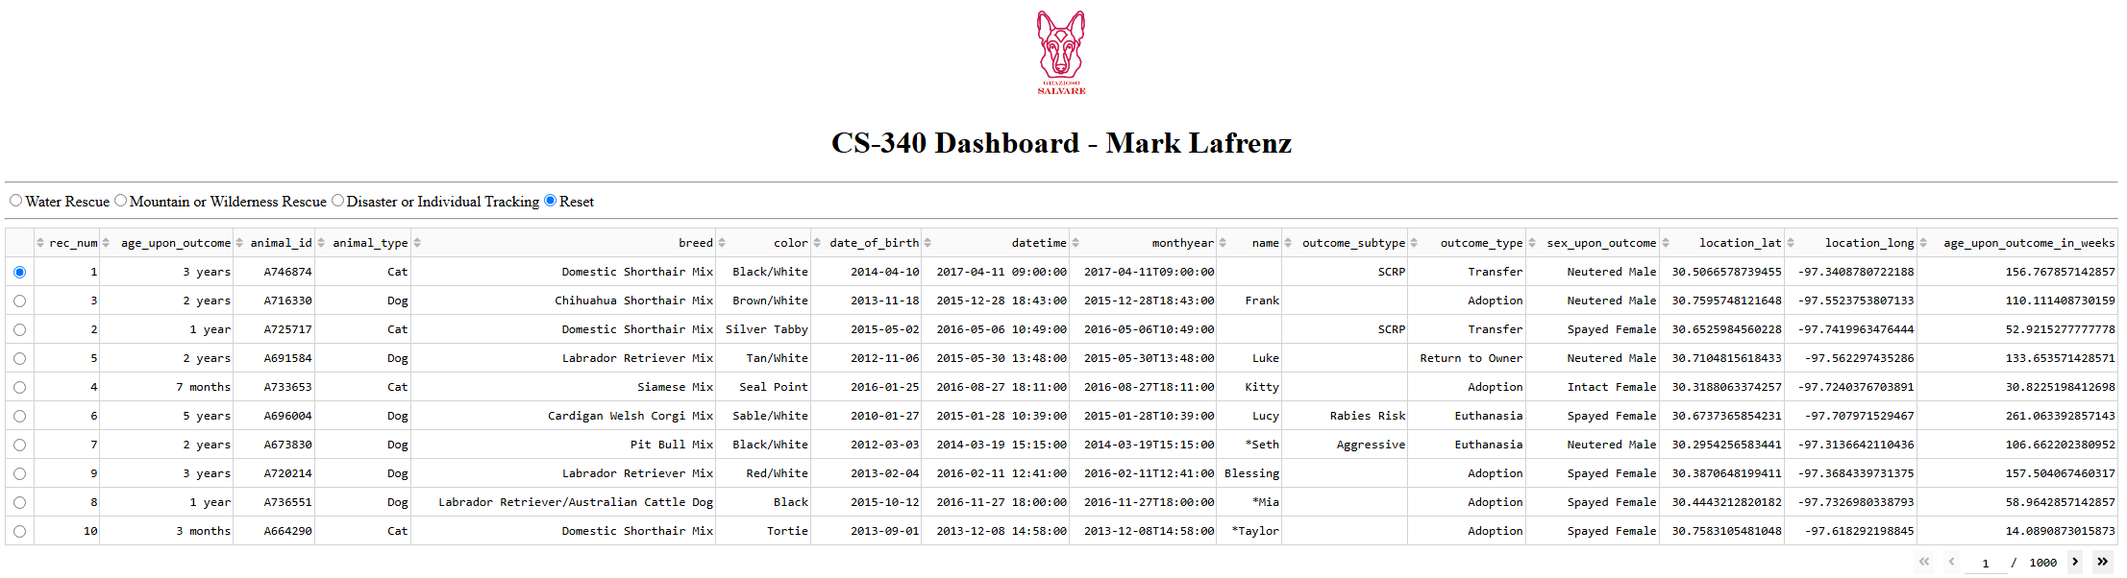
Starting Dashboard State
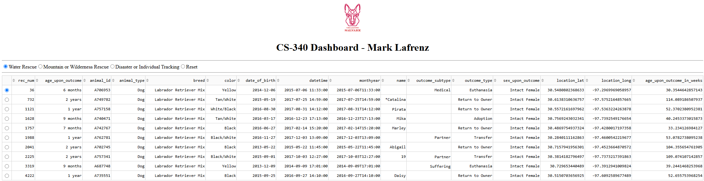
Water Rescue Filter
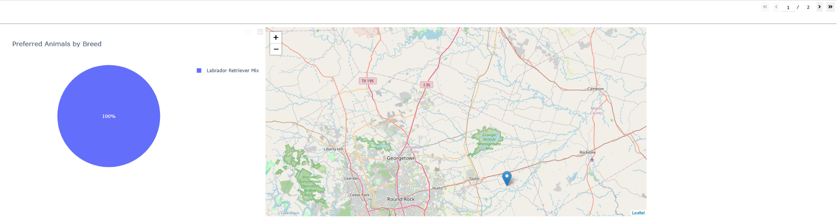
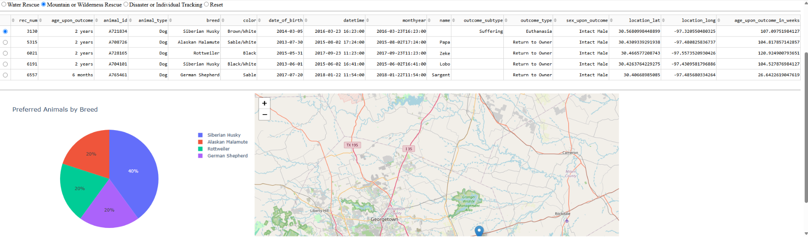
Mountain or Wilderness Rescue Filter
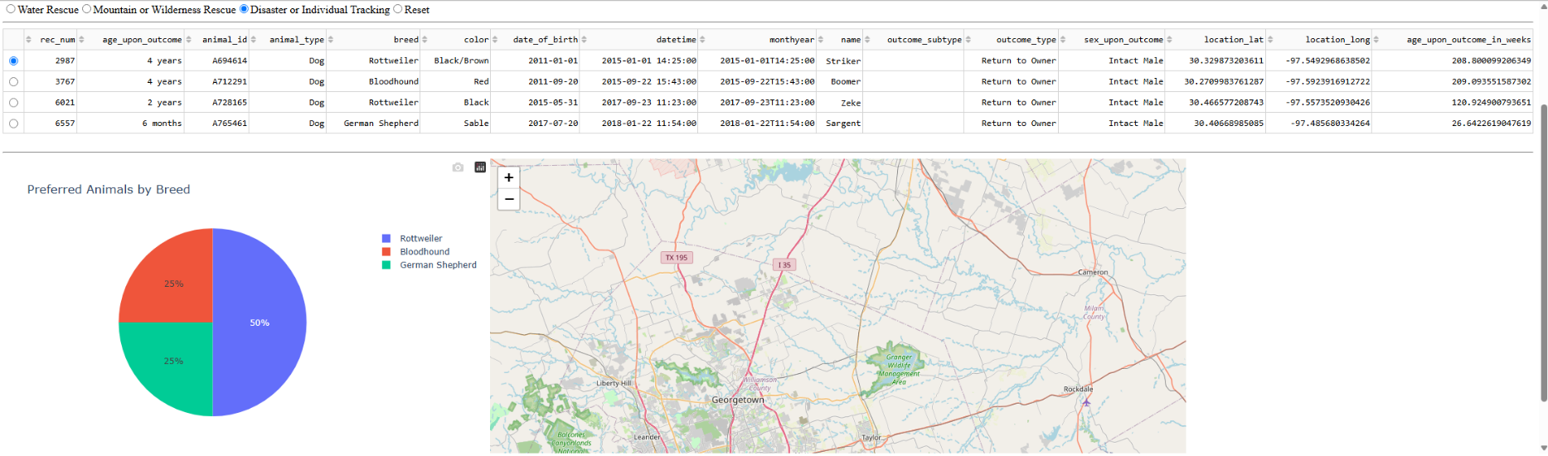
Disaster or Individual Tracking Filter
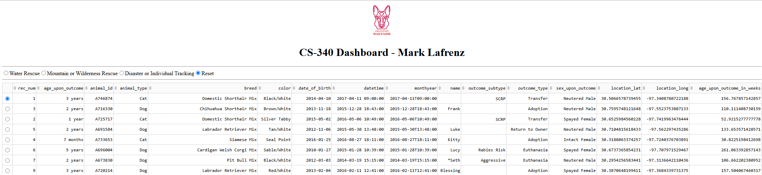
Reset Filter
